**Working Title**

Gesture to Communicate: Bridging the Gap in Smart Homes for Individuals with Hearing and Speaking Loss

**Hypothesis/Research Question**

To what extent can the integration of TinyML technology in wearable watches facilitate seamless and precise smart home operations for individuals facing hearing and speech challenges?

**Background / Preliminary Literature Review**

The rapid increase in internet-connected smart devices has led to a paradigm shift in user interfaces, with a growing preference for voice over visual interfaces to reduce costs(Bigham et al., 2017). However, this shift presents significant accessibility challenges for the approximately 466 million people worldwide with hearing impairments, underscoring the importance of developing more inclusive smart home technologies(Kraljević et al., 2020). Recent advancements in gesture recognition, particularly through edge computing and deep learning in wearable devices, offer promising solutions to these challenges.

Gesture recognition can be categorized into two primary methods: vision-based and non-vision-based. Compared with vision-based gesture recognition, utilizing accelerometers, and incorporate Tiny Machine Learning (TinyML), offer a low-cost and seamless solution(Jalal et al., 2019; Sharma et al., 2024). This is because decentralized processing offloads data analysis to edge devices, which can reduce bandwidth requirements and latency, and also decrease the total transmission time needed for wireless devices(Coffen and Mahmud, 2021). According to Kraljević et al (2020) sensory gloves have historically dominated in terms of performance, but they often do not align with Human-Computer Interaction (HCI) principles. However, using wearable watches to capture accelerometer data provides another effective and efficient way to communicate with smart home devices. (Alemuda and Lin, 2017; Nguyen-Trong et al., 2021).

The Apollo SignSound system research offers a prototype smart home for deaf users that can collect environmental sounds and alert users to events like boiling kettles and door knocking, showcasing the potential of smart environments to improve the daily lives of hearing-impaired users(da Rosa Tavares and Victória Barbosa, 2021). On the other hand, Pothong and Turner (2020) highlight persistent challenges for living with hearing loss, including concerns over privacy and the necessity for enhanced interoperability between assistive technologies and mainstream smart home devices. However, people with hearing loss have the same abilities as everyone else and like to take advantage of the technology at their disposal.

While existing technologies have improved the quality of life for hearing-impaired individuals to some extent, limitations and challenges persist, such as the accuracy of gesture recognition, the real-time responsiveness of systems, optimization of user interaction experiences, and the interoperability and universality of smart home devices. Especially in providing seamless and precise control over smart home operations for hearing-impaired individuals, further research is needed to explore more efficient gesture recognition methods and better user experience designs.

Moreover, while smartwatches and other wearable devices have shown great potential in gesture recognition and communication devices, how they can be better integrated into smart home systems to offer more natural and intuitive control remains an open research area. Therefore, this study aims to explore a new solution by integrating edge computing models into wearable watches, to achieve precise and seamless control over smart homes, particularly for individuals facing hearing and speech challenges.

**Research Design**

To answer the research question, a wearable watch will be designed and produced, utilizing the nRF52840 development board to capture data from its built-in accelerometer. The nRF52840 development board is small in size, making it highly suitable for the construction of wearable watches. Additionally, it is equipped with a Bluetooth module, enabling rapid communication with smart home devices.

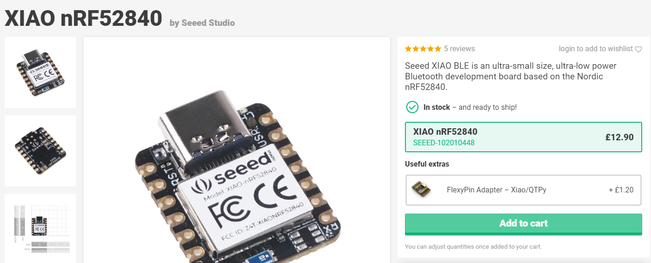

The gestures for controlling smart home devices will be designed based on basic sign language. Considering that sign language involves a significant amount of finger movement, and given the limitations of wearable watches in recognizing these movements, it is not my intention to recognize complete sign language. Instead, I will extract certain gesture information from sign language to design the gesture language for my system. For example, using “hello” to wake up the device, and “see you later” to turn off the device recognition.

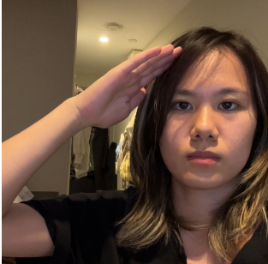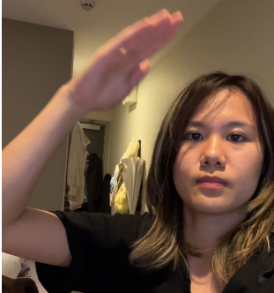“hello”

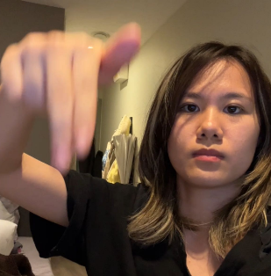”see you”

Regarding deployment, I considered implementing this in a real smart home environment (referring to Home Assistant), but due to the desired exhibition effect, time constraints, and my own programming capabilities, I decided to create a scaled-down smart home model controlled by Arduino. Additionally, a watch screen will be connected to my nRF52840 development board to display certain information.

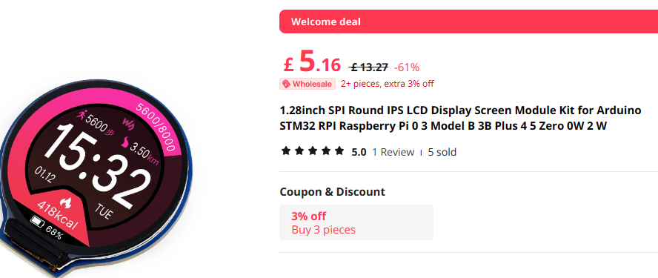

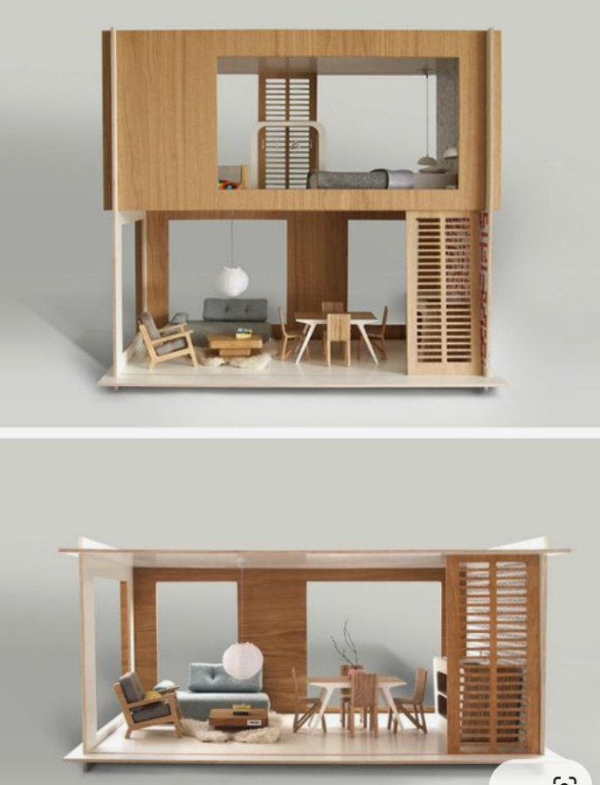

The smart home primarily includes sensor and actuator functions, allowing users to manipulate devices or access device information through gesture recognition. This includes functions such as opening and closing curtains, turning lights on and off, gathering environmental data, and detecting ambient sounds.

**Ethics Statement**

Considering ethical concerns, the study will anonymously collect gesture information to ensure it cannot be traced back to any individual. Furthermore, all data transmission and storage processes will employ encryption technology to prevent data breaches or unauthorized access. Additionally, all participants involved in the study will receive full information about the project before it begins and will have the opportunity to ask questions. Participant data will only be collected and used after obtaining explicit written consent.

**Timetable**

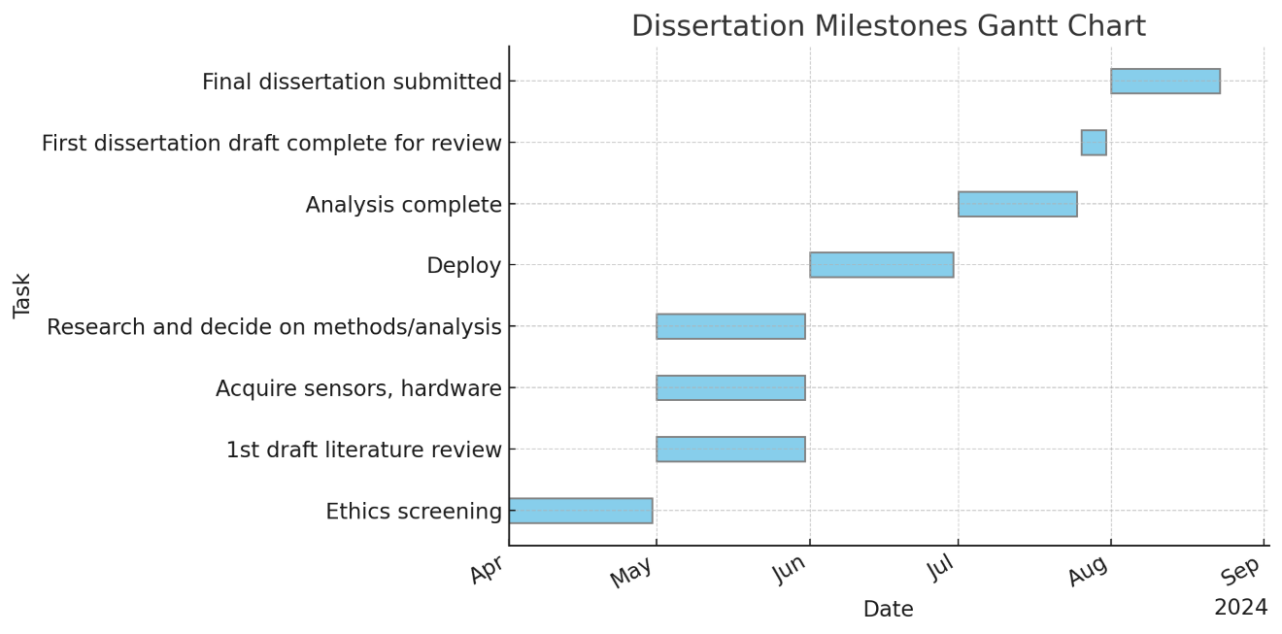

**References**

Alemuda, F., Lin, F.J., 2017. Gesture-Based Control in a Smart Home Environment, in: 2017 IEEE International Conference on Internet of Things (iThings) and IEEE Green Computing and Communications (GreenCom) and IEEE Cyber, Physical and Social Computing (CPSCom) and IEEE Smart Data (SmartData). Presented at the 2017 IEEE International Conference on Internet of Things (iThings) and IEEE Green Computing and Communications (GreenCom) and IEEE Cyber, Physical and Social Computing (CPSCom) and IEEE Smart Data (SmartData), pp. 784–791. https://doi.org/10.1109/iThings-GreenCom-CPSCom-SmartData.2017.120

Bigham, J.P., Kushalnagar, R., Huang, T.-H.K., Flores, J.P., Savage, S., 2017. On How Deaf People Might Use Speech to Control Devices, in: Proceedings of the 19th International ACM SIGACCESS Conference on Computers and Accessibility, ASSETS ’17. Association for Computing Machinery, New York, NY, USA, pp. 383–384. https://doi.org/10.1145/3132525.3134821

Coffen, B., Mahmud, Md.S., 2021. TinyDL: Edge Computing and Deep Learning Based Real-time Hand Gesture Recognition Using Wearable Sensor, in: 2020 IEEE International Conference on E-Health Networking, Application & Services (HEALTHCOM). Presented at the 2020 IEEE International Conference on E-health Networking, Application & Services (HEALTHCOM), pp. 1–6. https://doi.org/10.1109/HEALTHCOM49281.2021.9399005

da Rosa Tavares, J.E., Victória Barbosa, J.L., 2021. Apollo SignSound: an intelligent system applied to ubiquitous healthcare of deaf people. J. Reliab. Intell. Environ. 7, 157–170. https://doi.org/10.1007/s40860-020-00119-w

Jalal, A., Quaid, M.A.K., Sidduqi, M.A., 2019. A Triaxial Acceleration-based Human Motion Detection for Ambient Smart Home System, in: 2019 16th International Bhurban Conference on Applied Sciences and Technology (IBCAST). Presented at the 2019 16th International Bhurban Conference on Applied Sciences and Technology (IBCAST), pp. 353–358. https://doi.org/10.1109/IBCAST.2019.8667183

Kraljević, L., Russo, M., Pauković, M., Šarić, M., 2020. A Dynamic Gesture Recognition Interface for Smart Home Control based on Croatian Sign Language. Appl. Sci. 10, 2300. https://doi.org/10.3390/app10072300

Nguyen-Trong, K., Vu, H.N., Trung, N.N., Pham, C., 2021. Gesture Recognition Using Wearable Sensors With Bi-Long Short-Term Memory Convolutional Neural Networks. IEEE Sens. J. 21, 15065–15079. https://doi.org/10.1109/JSEN.2021.3074642

Pothong, K., Turner, S., 2020. Living with Hearing Loss in a Connected Home: White Paper (Report), UCL Department of Science, Technology, Engineering and Public Policy (STEaPP): London, UK. UCL Department of Science, Technology, Engineering and Public Policy (STEaPP), London, UK.

Sharma, S., Gupta, R., Kumar, A., 2024. A TinyML solution for an IoT-based communication device for hearing impaired. Expert Syst. Appl. 246, 123147. https://doi.org/10.1016/j.eswa.2024.123147